[](http://www.wcaaa.org/)

**REQUEST FOR QUOTATION**

**For**

**Integrated Care Management System (ICMS)**

**FOR**

**WCAAA**

**TABLE OF CONTENTS**

PART I: OVERVIEW 3

PART II: GENERAL GUIDELINES 38

PART III: RFQ RESPONSE GUIDELINES 40

APPENDIX A: ACKNOWLEDGEMENT OF BID INVITATION DUE (10/07/24) 45

APPENDIX B: SUPPLIER PROPOSAL COMPLIANCE SHEET 46

APPENDIX C: RFQ REQUIREMENTS 47

ATTACHMENT 1: PRICING RESPONSE DOCUMENT 51

ATTACHMENT 2: RFQ CLARIFICATION QUESTIONS DOCUMENT 51

ATTACHMENT 3: VENDOR SOLUTION OVERVIEW DOCUMENT 51

# PART I: OVERVIEW

#### Project Goal

The Western Connecticut Area Agency on Aging (WCAAA), a 501(c)(3) non-profit organization, is transitioning and enhancing its current suite of custom business applications supporting the Connecticut Home Care Program (CHCP) to the Salesforce platform. This migration aims to achieve the following objectives:

**1. Streamline Access to Care:** Accelerate the onboarding process to improve client access to care.

**2. Enhance Quality of Care:** Enable more accurate and timely communication with stakeholders to elevate care quality.

**3. Optimize Service Delivery:** Ensure the provision of ‘the right service at the right time’ for clients.

**4. Boost Operational Efficiency:** Improve cost-effectiveness and operational efficiency to better meet client needs.

#### Project Description

WCAAA will transition its current line of business applications and processes to the Salesforce platform, making significant improvements and enhancements to support the four primary project objectives. Along with this conversion and upgrade, WCAAA’s data will be migrated to the new platform, and staff will receive comprehensive training on the updated application.

WCAAA is seeking a qualified service provider (SUPPLIER) to deliver Salesforce development services in alignment with the requirements outlined in this Request for Quotation document.

## **Scope of work**

This RFQ is for procurement of the following services:

**Phase 1:** **Requirements Gathering and Analysis**

* Collect and analyze requirements to establish a clear understanding of project needs and objectives.

**Phase 2:** **Analysis and** **Design**

* Define processes and design the Salesforce application, including user interface (UI), database structure, data flow, and test plans.

**Phase 3: Development**

* Execute coding, testing, and quality assurance.
* Conduct development reviews and optimize workflows.
* Perform pilot testing.

**Phase 4: Implementation**

* Provide user training and execute application implementation.
* Manage data migration and ensure user acceptance.

**Phase 5: Support**

* Documentation
* Maintenance and Support (Recurring Costs)

Note: * A phased delivery of feature sets is preferred over a single, large-scale launch.

## **Current Environment (Current State)**

#### ICMS High Level Overview

To facilitate a clear understanding of the work to be performed, we will begin by describing the current state of CHCP-related systems and processes at WCAAA.   
  
WCAAA currently utilizes a combination of custom-built applications and predominantly manual, paper-based processes to manage the needs of its CHCP client population. Most of these applications are developed in MS Access, with the primary application being The Plan of Care. The following diagram illustrates the major systems within WCAAA and their interactions with state and provider systems.

The Plan of Care is an MS Access-based application that serves as the core of WCAAA’s software systems. Currently, the application performs the following functions:

1. Client Demographic Tracking: Maintains comprehensive records of client demographic information and relevant details.

2. Service Provider Tracking: Manages information about service providers, including the services they offer and details about those services.

3. Service Order Management: Records all service orders issued for clients, including associated cost and administrative details.

4. Billing Facilitation: Supports WCAAA’s internal billing processes for provided services.

5. Reporting: Enables reporting for both internal stakeholders and government compliance requirements.

6. User Access Control: Provides various levels of user access to ensure effective controls and adherence to HIPAA regulations.

The Plan of Care allows for a variety of user access levels to promote effective controls and meet HIPAA compliance requirements.

The Plan of Care has certain limitations, including that it does NOT:

1. Allow for efficient redistribution and assignment of cases among staff.

2. Monitor assessment data, due dates, and associated tasks seamlessly.

3. Facilitate communication of case-related updates between providers and staff.

4. Incorporate all WCAAA contracted programs, categories, budgets, and available services.

5. Offer robust document management capabilities for storing and organizing case files.

6. Include features for managing forms to streamline data collection and compliance.

7. Fulfill the agency's reporting requirements with customizable and automated reports.

8. Provide CRM features for tracking client interactions and activities performed on their behalf.

9. Help staff and management gauge their workload with analytics and performance metrics.

The secondary application, RS Import Copay, comprises a suite of tools designed to manage billing for the services provided by WCAAA. Additionally, the Upload Utility, a crucial tertiary application, functions as the integration link with the State of Connecticut’s Medicaid billing system: HP Medicaid Management Information System (HP MMIS).

#### Plan Of care Usage Statistics

**Plan of Care Statistics (WCAAA):**

**Software**  MS Access

**Users**         40

**Clients**       2,000 current    5,500 including past clients

**Records:**

**Service Orders**           8,500 per year   50,000 total

**Client Assessments**    Archived Data Only

 Notes:

Service Orders undergo frequent modifications throughout their lifecycle, including starts, stops, and various edits. On average, about 70 new orders are created each workday, while around 70 are closed and an additional 40 are modified.  
  
Additionally, there are thousands of MS Word and PDF documents. These will need to be either linked or imported into the new system based on cost.

## **Future Environment (Future State)**

The key concept to grasp is that while the initial adoption of Salesforce is driven by the needs of the Connecticut Home Care Program contract, the implementation should be designed with a broader goal in mind: to support agency-wide adoption of Salesforce. The vision is to enable all agency programs to be managed through the Salesforce platform, providing staff with a unified view of the clients we serve. Over time, the agency plans to transition additional applications and services to the Salesforce platform.

Before delving into the future state, it's crucial to first understand the Care Management Process at a high level.

The Care Management Process consists of two main phases: 1) Referral and On-Boarding, and 2) Ongoing Monitoring and Support. Tasks related to post-support and off-boarding are considered routine administrative functions and are not detailed here.

The new system must comprehensively support these phases and additional functions by:

1. Minimizing manual data entry and reducing time spent on repetitive tasks
2. Facilitating the collection and transfer of information among stakeholders in a HIPAA-compliant and efficient manner
3. Offering foundational intelligence to manage the complex set of rules associated with the Connecticut Home Care Program (CHCP)

## **ICMS Future State Feature Set (level of Effort Development)**

WCAAA has invested significant resources in reviewing its software systems and internal processes to document its desired future state. Embedded below is an Excel document featuring a matrix that outlines the functional areas and goals for the overall project, including details on the Current State, Future State, and references to supporting documentation.



The documentation referenced in the Description/Example column is provided on the following page in the Exhibits section. The samples included are intended to illustrate the level of effort required to meet the project's goals and should not be interpreted as final or literal representations. For instance, screen mockups are provided as potential starting points for user interface design, and process flows will need to undergo further validation before final implementation. Screenshots and examples from current software represent a basic framework and are not sufficient for the final product.

The samples also reflect WCAAA’s understanding of its current environment and the depth of its vision for the future state. They offer bidders a clear perspective on the complexity of the processes and the level of effort required to translate them into deliverables.

The items listed as "Out of Scope" for this RFQ are intended to indicate that, while direct work on these items is not included in this RFQ, the systems and interactions related to them must be considered when designing the in-scope feature sets.

*****A signed non-disclosure agreement (NDA) is required before WCAAA will release a copy of its Plan of Care MS Access system to potential bidders. The NDA attached below must be signed by any interested bidder prior to the release of the Plan of Care MS Access system data.  
  


## Project deliverables

A successful project will deliver a comprehensive solution that encompasses:

1. All areas specified in the ICMS RFQ Functional Area Matrix.

2. Conversion and import of all relevant current state data.

3. Training for all WCAAA staff on the utilization of the solutions.

4. Training for WCAAA technology administrators on the management of the solution.

5. Comprehensive documentation of the completed solution.`

## exhibits

#### **EXHIBIT 1** PROC1: Referral and Initial Call Process

In the referral process, WCAAA will receive referrals from the Clinical Operations Unit (COU) via fax or electronic file in the future. Additionally, WCAAA may occasionally receive intra-agency transfers directly from other Access Agencies. The process will conclude once the initial call to the client is completed.

Functional Requirement: Referral Assignment  
1.0 Referral Future Process

|  |  |
| --- | --- |
| REF 1.0 | Create Referral and Initial Call |
| Process  1.0  Referral  Process | The Plan of Care (POC) system will include a section for Referrals to create new clients and referrals, and to review, update, and delete information.   1. When a referral is received, the Care Manager Assistant (CMA) will input the client and referral information into POC and indicate the status and type (e.g., new referral, status review, re-assessment, self-directed, or intra-agency transfer). For intra-agency transfers, the appropriate Care Manager Supervisor will manage the communications and documents required from other agencies and complete an Intra-referral DSS COU-Access form (W-1547A). The Care Manager Supervisor will activate the client by assigning a Care Manager (CM) once all required paperwork has been received and will notify DSS through Ascend.    1. POC: The system will allow for search capabilities to determine if the client is already a WCAAA client (e.g., WCAAA Customer#, EMS#, Name, SS#, DOB). A WCAAA client can belong to multiple programs.    2. POC: The system will indicate the types of programs the client is active in (e.g., Respite, CHCP, etc.).    3. POC: The system will automatically assign a unique Customer ID#, as a client may belong to multiple programs at WCAAA.    4. POC: The system will automatically assign a unique Referral ID, allowing the referral to be tracked.    5. POC: The system will automatically assign an activity, based on referral type, to the Care Manager Supervisor based on the customer's zip code and populate their dashboard as an unassigned activity.    6. The system will populate the screen with the number of referrals based on past client activities. 2. The CMA will log the date and time of the referral when it is received from the COU or the referring agency. 3. The CMA will assign the referral to the appropriate Dedicated Assessor (DA).    1. POC = The system will automatically populate the DA's dashboard with the referral as Pending Unassigned Activity. 4. The CMA will update the Care Notes or pending "Activities" for the Care Manager Supervisor. 5. The CMA will scan the referral documents and attach them to the Referral Section in POC. 6. The CMA will save the referral. 7. The CMA will make an initial call to the client within 24 hours to introduce WCAAA and provide further details about the program. Additionally, the CMA will arrange a visit with the assigned DA. 8. The CMA will update the Initial Call Date/Time and status in POC. 9. The CMA will update the Care Notes with any comments the Care Manager needs to be aware of (e.g., unsuccessful attempts to reach the client). 10. The CMA will save the referral.     1. The system will automatically change the status of the client to “Pending Assessment.”     2. The system will create a line in the Care Notes with the DA's name, the date of the referral initial call, and the date/time the referral was saved. |

Referral Screen

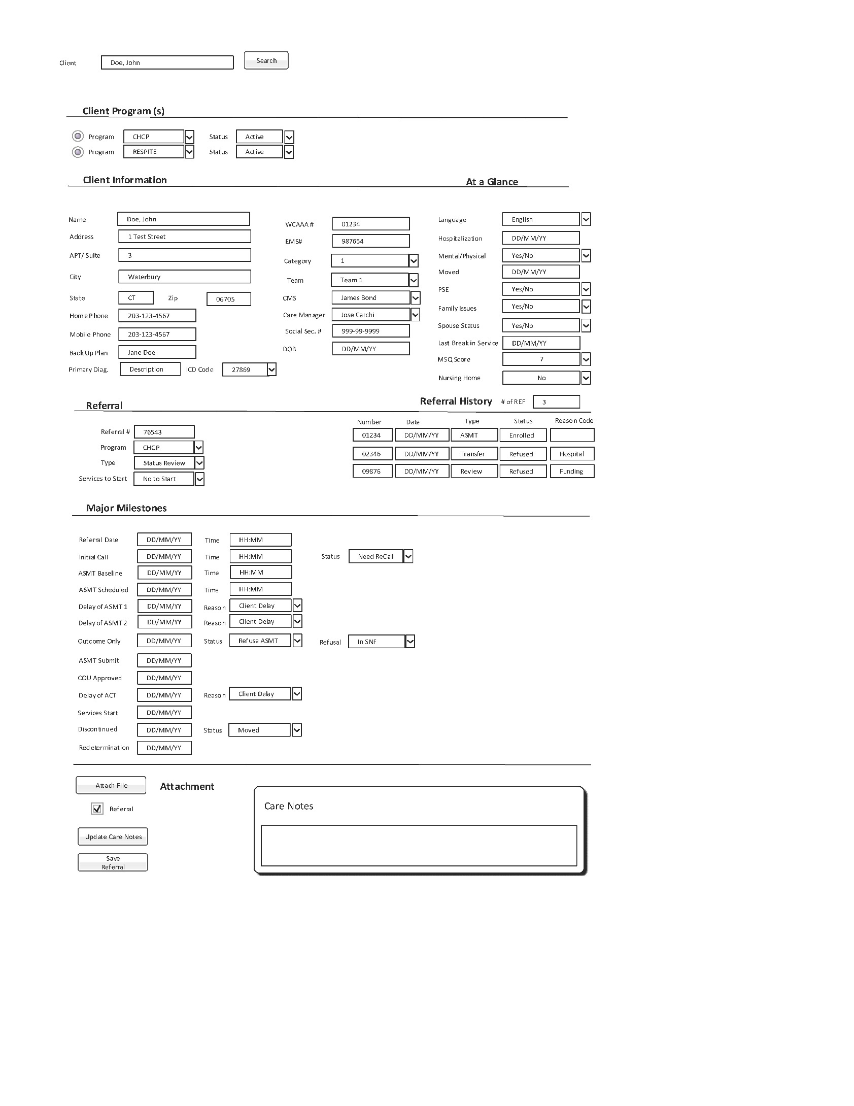

#### **EXHIbit 2** PROC 2.0 Assessment

In the assessment process, the CMA will initiate by assigning the referral to the Dedicated Assessor. The CMA will also close out the assessment process if the client decides not to proceed. For intra-agency transfers, the Care Manager Supervisor (CMS) will assign a Care Manager to conduct a home visit. (See Exhibit 1, Bullet 1)

|  |  |
| --- | --- |
| REF 2.0 | Assessment (Pre-Visit) |
| Process  2.0  Assessment | The POC system will include a section for Referrals to create new clients and referrals, and to review, update, and delete information.   1. The CMA will identify pending referrals in their dashboard. 2. The CMA will assign a Dedicated Assessor (DA) to the referral. For intra-agency transfers, proceed to step 4.    1. POC = The system will display a section in the CMA’s dashboard showing the number of open referrals for each Care Manager for the month. 3. The CMA will enter a 30-Day Delay Request into the DSS ASCEND system (non-WCAAA) and then update the referral information in the Milestone section. Intra-agency transfers do not require Delay Requests.    1. POC = The system will update the Delay Request referral date to the original referral date plus 30 days.    2. POC = The system will set an ALERT flag for the Care Manager when the delay of assessment reaches 22 days from the original referral date. 4. The CMA or Care Manager for intra-agency transfers will contact the client to schedule the assessment or home visit, input the scheduled date/time, and update the Care Notes in POC. If the client refuses the assessment, proceed to the Assessment Declined process.    1. The system will populate the Care Notes with the scheduled date and referral details (see Care Notes section). 5. The CMA or Care Manager will follow the Assessment Process based on the Services Start indicator in the referral (Yes to Start or No to Start). Intra-agency transfers are considered "Yes to Start."   **ASSESSMENT DECLINED**   1. The CMA is responsible for contacting the client to confirm if they still wish to proceed with the assessment, noting that the client may decline. 2. The CMA will complete the Outcome Form and notify the Care Manager Supervisor (CMS). 3. If the assessment is declined, the Care Manager will update the Assessment Milestone with the reason for discontinuance and update the Care Notes. 4. The CMA will update the “Outcome Only” date field in the Milestone section in POC.   a. POC: When the date field is updated, the system will generate an activity for the CMA to review and authorize in ASCEND.   1. The CMS will retrieve the ASCEND activity in the CMS Dashboard and indicate that it has been submitted along with the date. |
|  |  |

Referral Screen

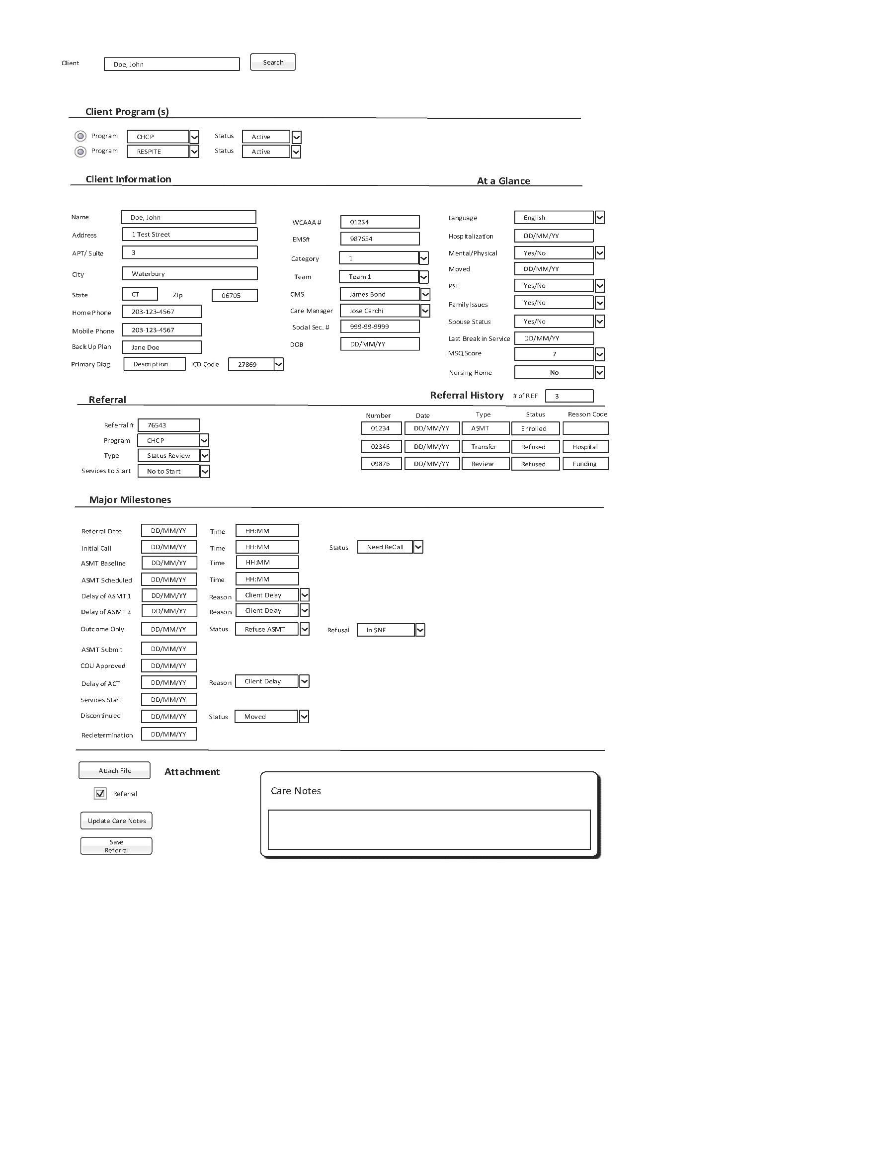

#### **exhibit 3** PROC 3.0 Assessement Process (Visit) Yes to Start

During the Assessment Visit (Yes to Start) process, the Care Manager meets with the client and conducts a comprehensive assessment. This concludes with either WCAAA providing ongoing care management services or closing out the assessment process.

Approximately 15% of Referrals are approved to start care management services.

Functional Requirement Assessment

3.0 Assessment Visit – (Services = Yes to Start) Future Process

|  |  |
| --- | --- |
| AS | Assessment (Visit) Yes to Start |
| Process  3.0  Assessment  (Yes to Start) | This process involves the Client/Referral and Assessment sections for creating, reviewing, updating, and deleting information.   1. The DA will visit the client and conduct the assessment using the Assessment Tool and the relevant DSS paper documents.    1. POC = The system will update the Assessment Tool and any electronic documents with existing data from the Client Referral (refer to the Document Section for a list of documents). 2. The DA will determine the Category, Costs, and Service Providers, and complete the Assessment documents.    1. POC = The system will generate forms for the DA to input data into the Goal Sheet and Proposed Plan of Care. 3. The DA will call the Service Providers to confirm the Services. 4. The CMA will enter a 30-day Delay Request into the DSS ASCEND system (non-WCAAA) if the paperwork cannot be completed on time, and then update the delay date information in the POC Milestone section.    1. POC = The system will update the Delay of Assessment date to reflect the original referral date plus 60 days. 5. The DA will update the Care Notes in POC and complete all final paperwork.    1. POC = The system will populate the Care Notes with the Delay Request submission date and Referral information (refer to the Care Notes Section). 6. The DA will create Service Orders for the Plan of Care in POC.    1. POC = The system will generate a Service Provider Face Sheet and email it to the Service Provider. 7. The CMA will enter service orders into the DSS MMIS (excluding the WCAAA system). 8. The CMA will input data into DSS ASCEND, including the Checklist, Outcome Form, and Cost Worksheet, and will attach the Plan of Care. 9. The CMA will manually input the ASCEND submission date into the Plan of Care (POC) Assessment Screen.    1. POC = Upon submission, the system will generate an activity for the CMS to review and authorize in ASCEND. 10. The CMS will retrieve the ASCEND activity via the CMS Dashboard, marking it as submitted and recording the submission date. 11. The CMS will update the Assessment Submitted date in the POC.     1. POC = This update will trigger a change in the client status from "Yes" to "Start Clients" to "Care Management Services." 12. The CMS will manually input the Assessment Tool data into the POC.     1. POC = The POC will contain an electronic version of the Assessment Tool, capturing the necessary data (currently varying in length, with a maximum of 147 pages).     2. POC = The document will be prefilled with client information obtained from the referral. 13. The CMA will scan and upload any additional required documents into the POC Assessment documentation section.   **CLIENT DECLINES CARE MANAGEMENT SERVICES (ASSESS ONLY)**   1. If the client declines Care Management Services (CMS), the DA will update the Outcome Only date and status to "Assessed Only/Refuse CMS," including the reason for discontinuation in the Care Notes. 2. The DA will then complete the Outcome Form in ASCEND. 3. Once the data is entered into ASCEND, the DA will mark the task as completed in the POC.   a. Upon completion, the system will generate an activity for CMS review and authorization in ASCEND.   1. The CMS will access the ASCEND activity from the Dashboard and will record the POC submission date along with the corresponding reason code.   a. The system will subsequently update the client's status to "Assess Only" and will populate the Discontinuance code from nine available options.   1. The CMA will scan and upload any additional documents necessary for the POC Assessment documentation section. |
|  |  |

Assessment Screen

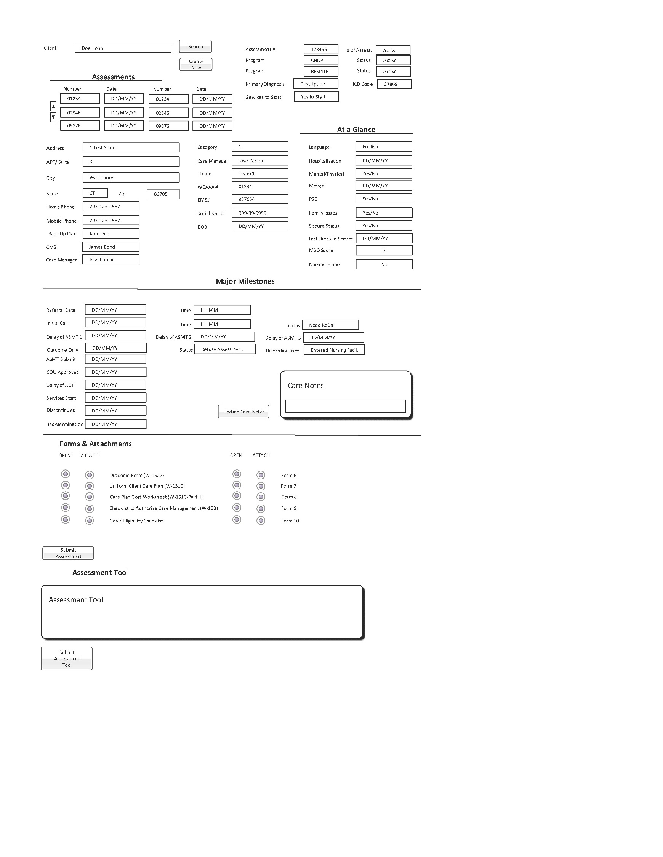

##### **exhibit 4** PROC 4.0 Assessement Process (Visit) No to Start

In the Assessment Visit (No to Start) process, the DA conducts a visit with the client and relevant individuals to assess needs. This process concludes with either WCAAA providing ongoing care management services or formally closing the assessment. It is important to note that most referrals are initially not approved to commence care management services.

Functional Requirement Assessment

4.0 Assessment Visit – (Services = No to Start) Future Process

|  |  |
| --- | --- |
| AS | Assessment (Visit) No to Start |
| Process  4.0  Assessment  (No to Start) | The POC system will have a section for Assessments to create new, review, update, and delete information.   1. The DA will visit the client and perform the Assessment utilizing the Assessment Tool and appropriate DSS paper documents.    1. POC = the system will update the Assessment Tool and any of the electronic documents with existing data from the Client Referral. (See Document Section for list of documents) 2. The DA will determine the Category, Costs, and Service Providers and complete the Assessment documents.    1. POC = the system will create forms where DA can input data for the Costs Worksheet, Checklist, Outcome Form and Proposed Plan of Care. 3. The CMA will enter an additional 30 Delay Request in the DSS ASCEND system (non-WCAAA) if paperwork cannot be completed in time, and then update the Assessment information in the Milestone section.    1. POC = the system will the update the Delay Request Referral date with the original referral date plus 60 days. 4. The DA to input data into DSS ASCEND (Outcome Form, Cost Worksheet) and attach Proposed Plan of Care. 5. When the data is inputted into the ASCEND, the DA will check off completed in POC.    1. POC = the system will send an activity to the CMS to review and authorize in ASCEND. 6. The CMS will access the ASCEND activity in CMS Dashboard and indicate submitted and date in the Assessment Milestone.    1. POC = the system will send an activity to the Team Eligibility for a pending unassigned activity.    2. POC = the system will change the client status to “Pending Approval”.   **ELIGIBILTY PROCESS**   1. The Intake Team manages the approval process from COU.    1. POC = the system will create a dashboard for Eligibility Team to manually manage the milestone dates. (see Intake Team Dashboard)     **ELIGIBILTY PROCESS END**   1. Upon receiving the approval letter from COU, the CMA will input the "COU Approval" date into the POC and send a copy of the letter to the DA.   a. In the POC, the system will update the client status to "Pending Activation."  b. The system will notify the DA to call the client and determine the activation date.   1. The DA will contact the client to input the activation date or the client discontinuance code (refer to the Declines Section). 2. The DA will call the service provider(s) to confirm the services. 3. The DA will assess whether a "Delay of Implementation" form is required to extend the start date by an additional 30 days.   a. In the POC, the system will have a milestone field for the CMS to input the "Delay of Implementation" date and indicate the 30-day extension.  b. The system will send an alert to the CMA 22 days after initiating the Delay of Implementation.   1. The CMS will input data related to the Delay of Implementation into ASCEND and the POC. 2. The CMS will enter the Client Milestone Services "Start Date" when services are referred and code the services accordingly.   a. In the POC, the system will change the client status to "Active."  b. The system will populate the Care Notes with the ASCEND input submission date (refer to the Care Notes Section).   1. The DA will update the Care Notes in the POC. 2. The DA will complete all final paperwork. 3. The DA will create service orders for the Plan of Care in the POC and scan any relevant documents into the POC.   a. The system will initially input available information to create service orders based on the Uniform Care Plan Document.  b. The system will generate a Service Provider Face Sheet and email it to the service provider.   1. The DA will input service orders into DSS MMIS (non-WCAAA system). The service orders must be entered into MMIS within 48 hours of the activation date. 2. The DA will update the MMIS date field in the Assessment section. 3. The DA will input data into DSS ASCEND (Checklist, Outcome Form, Cost Worksheet) and attach the Proposed Plan of Care and Applied Income Worksheet. 4. The DA will manually input the ASCEND date on the POC Assessment screen.   a. In the POC, the system will send an activity to the CMS for review and authorization in ASCEND.   1. The CMS will retrieve the ASCEND activity from the CMS Dashboard and indicate the submitted date in the POC. 2. The Care Manager will bring the paper file folder to WCAAA for the weekly meeting and provide it to the CMS for review. 3. The CMA will input Assessment Tool data into the POC. 4. The CMA will scan and upload any additional documents needed into the POC Assessment documentation section.   **CLIENT DECLINES CARE MANAGEMENT SERVICES (ASSESS ONLY)**   1. If the client declines Care Management Services during a call with the Care Manager, the Care Manager will update the Outcome Only date and status to "Assessed Only/Refuse CMS," including the reason for discontinuation in the Care Notes.   a. In the POC, the system will change the client status to "Refused."   1. The DA will complete the Outcome Form in ASCEND. 2. Once the data is entered into ASCEND, the DA will mark the task as completed in the POC.   a. In the POC, the system will create an activity for the CMS to review and authorize in ASCEND.   1. The CMS will retrieve the ASCEND activity from the CMS Dashboard and will record the submission date and reason code in the POC.   a. In the POC, the system will update the client status to indicate "Assess Only" and the refusal code.   1. The CMA will scan and upload any additional documents required into the POC Assessment documentation section. |
|  |  |

Assessment Screen

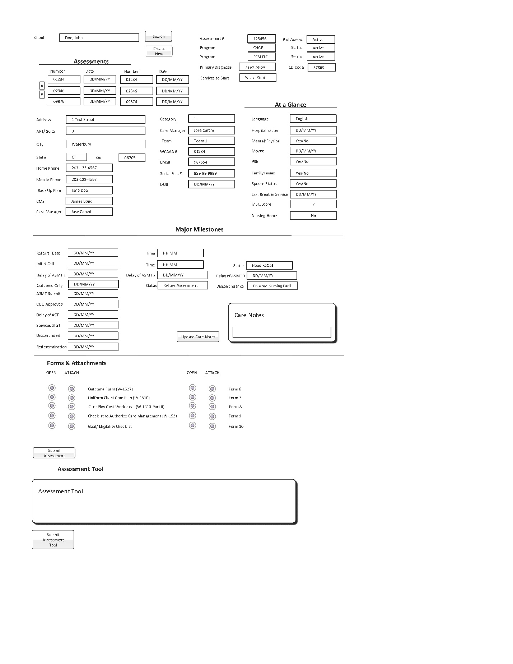

#### **exhibit 5** PROC 5.0 Create Service Orders

In the Care Plan/Create Service Orders process, the Care Manager utilizes the Client Care Plan developed during the Assessment Process. The Client Care Plan consists of services that must be converted into Service Orders in the POC. These Service Orders include procedures, service providers, rates, costs, and details regarding frequency and duration. The Service Orders are issued to service providers to authorize services, facilitate client in-kind contributions, and bill WCAAA care management services to DSS. Service Orders must be entered into both the POC and MMIS. The process concludes for WCAAA Care Management services when the billing file is submitted for processing to DSS for care management services.

5.0 Creating Service Orders Future Process

|  |  |
| --- | --- |
| SO 5.0 | Creating Service Orders |
| Process  5.0  Service Orders | This process will utilize the Care Plan screen to create, review, update, and delete information related to service orders. The following basic assumptions for the Service Orders must be supported in the new POC:   * 1. In the POC, Service Orders are designated for WCAAA Care Management Services, Client In-Kind, or Service Providers.   2. The POC system does not manage any financial transactions.   3. Each Service Order will have a unique service order number.   4. Multiple Service Orders can comprise a single Care Plan.   5. Only one type of Procedure Code may be included in a Service Order.   6. Each Service Order will be assigned to a specific WCAAA Program.   7. CHCP Program Service Orders may only be initiated for an extended period.   8. The system must accommodate rate changes.   9. The system should create a query for the current Access Billing System to retrieve billing information from the POC database.   10. The system needs to handle calculations and tracking related to monthly cost caps.   11. The system will include a text box to capture the Client Backup Plan and identify needs for each issued Service Order.  1. The Care Manager completes the assessment and determines the types of Service Orders required. Once the Proposed Plan of Care is finalized, the Care Manager will input the Service Orders. 2. The Care Manager will create Service Orders for the client.    1. The system will automatically retrieve any available data from the client and the Uniform Client Care Plan.    2. The system will generate a Service Provider Face Sheet and email it to the Service Provider. 3. When the Service Orders are entered, the Care Manager ensures that the total monthly costs across all Service Orders do not exceed the monthly cost cap.    1. POC = The system will support tracking of monthly costs compared to the monthly cap, broken down by Waiver and non-Waiver:       1. Monthly Recurring = Total projected costs minus one-time authorizations.       2. Monthly Projected = Total Costs.       3. Monthly Cap = Based on Category and/or approvals by COU.  |  |  |  |  |  |  |  |  |  |  | | --- | --- | --- | --- | --- | --- | --- | --- | --- | --- | | Frequency | Hours/Day | X | Unit Time | X | Unit Rate | X | Factor | = | Monthly Costs | | Weekly | 1 |  | 2 |  | $ 10.00 |  | 4.3 |  | $ 86.00 | | Monthly | 1 |  | 1 |  | $ 10.00 |  | none |  | $ 10.00 | | One Time | 1 |  | 1 |  | $ 20.00 |  | none |  | $ 20.00 | |  |  |  |  |  |  |  |  | Total Costs | $ 116.00 |  * 1. POC = Charges should be calculated on a weekly basis and multiplied by 4.3 to determine the monthly cap. This factor is used to average the weeks in a month over a calendar year, as required by DSS.   **DISCONTINUING SERVICE ORDERS (Hospitals and Nursing Homes)**   1. There are instances when clients experience a lapse in services, such as being hospitalized for several weeks, during which WCAAA and Service Providers cannot bill for services. New orders are not required for this situation; however, the design options need further development. 2. The proposed approach is to keep the orders open while implementing a status indicator for the Service Order, along with dates indicating the lapse in service from when services end to when they will resume.    1. POC = The system will need to incorporate a status with a date range indicator to flag periods when services should start and stop.    2. POC = The system must support reporting capabilities to exclude this status and date range from billing services. 3. The Care Manager will be responsible for manually closing orders and opening new ones in MMIS for each occurrence.   **RATE CHANGES**   1. The State may introduce rate changes for services, necessitating updates to the POC system with the new rates. Most rate changes are implemented as a percentage uplift to existing services. 2. The approach to implementing rate changes is to update the pricing table with an effective date, ensuring that all future activities on orders are calculated at the new rates. 3. The timing of updates needs to be coordinated with MMIS changes. |
|  |  |

Care Plan Service Orders

#### **exhibit 6** PROC 6.0 Care Notes

In the Care Notes Process, it is essential to document all interactions with the client. This includes phone calls, visits, activities, and quality reviews. Comprehensive recording ensures accurate tracking and continuity of care.  
6.0 Care Notes Future Process

|  |  |
| --- | --- |
| CN 6.0 | Care Notes |
| Process  6.0  Care Notes | This process will utilize the Care Notes screen for creating, reviewing, updating, and deleting information as needed.  The new Plan of Care (POC) must support several fundamental assumptions for the Client Care Notes:   * 1. Each Client Care Note is associated with a single client.   2. The system will provide version control for all changes made to Care Notes to facilitate auditing.   3. The system will include approximately ten templates to be integrated into the Care Notes, accommodating specific scripts or forms.   4. The system will allow modifications to a Care Note Object after submission, with version control to ensure that the original object can be reviewed.   5. The system will enable employees to assign follow-up activities within the Care Notes.   6. Assigned activities in the Care Notes will be displayed in the individual’s Activity List.   7. The system will organize Care Notes chronologically based on the activity date rather than the submission date. For example, if an assessment is conducted on July 1 and comments are added on July 31, the Care Note will be recorded under July 1 while retaining the timestamp of the submission.   8. A visual indicator for the Client's name will be included on every page printed or when viewed online.   9. The system will allow for embedded links to documents within the Care Notes.   10. A pop-up screen will be available for assigning follow-up activities to WCAAA employees. |
|  |  |

6.0 Client Care Notes

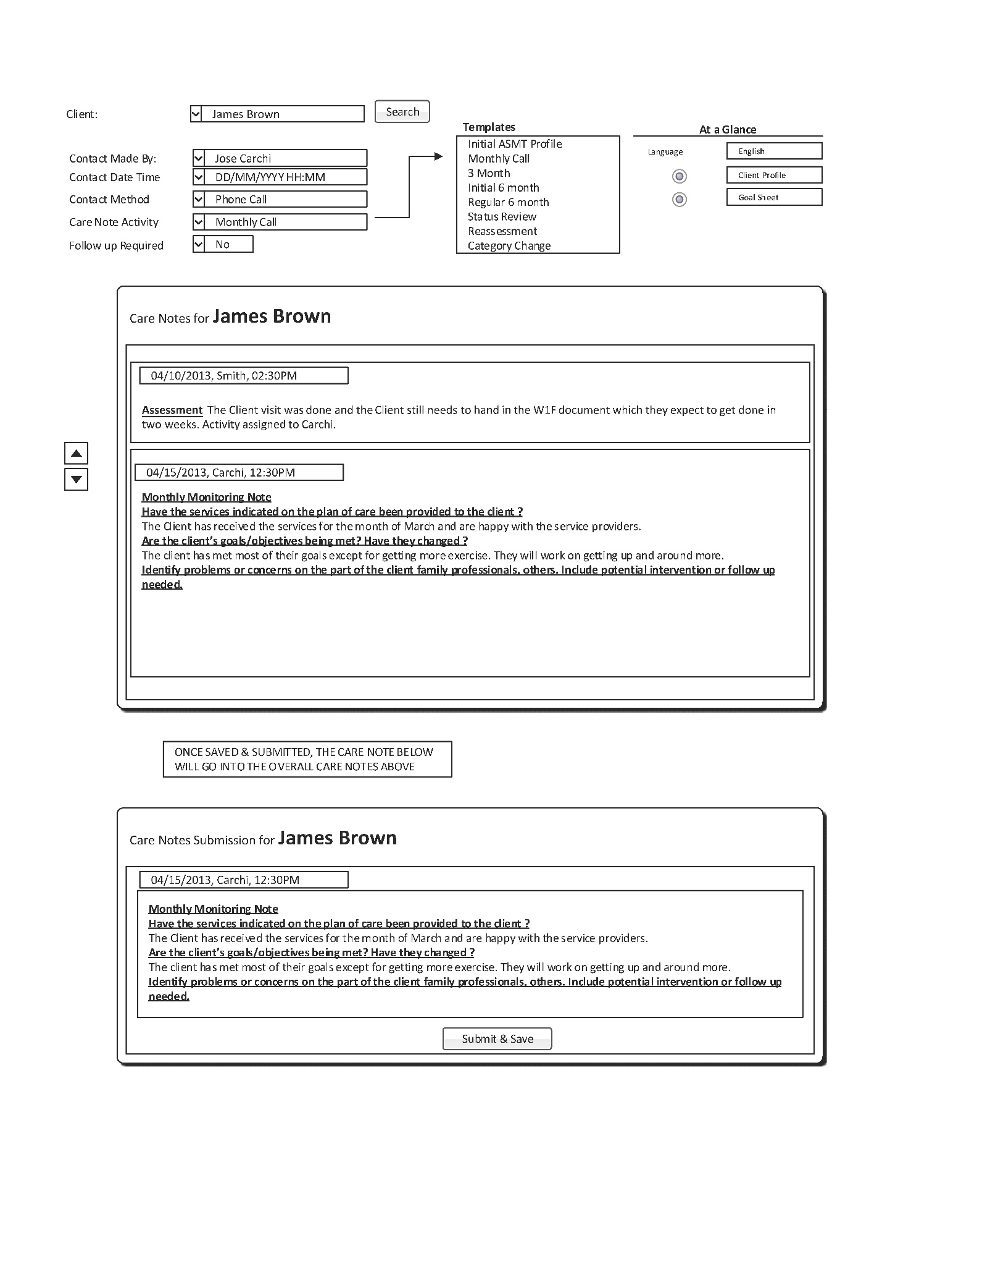

#### **exhibit 7** PROC 7.0 Dashboards

In the Care Management Processes, there is a need for a series of dashboards designed to assist employees in managing their activities and providing a "snapshot" of key performance indicators.

7.0 Dashboards

|  |  |
| --- | --- |
| DB 7.0 | Dashboards |
| Dashboard  7.0  Dashboard | This following are dashboards for:   * Client Dashboard * Care Manager Supervisor * Care Manager * Care Manager Assistant * Eligibility Supervisor * Eligibility Assistant   There are some basic assumptions for the Dashboards that need to be supported in the new POC:   1. The basic building blocks in the dashboards are utilized across multiple dashboards. |
|  |  |

Client Dashboard

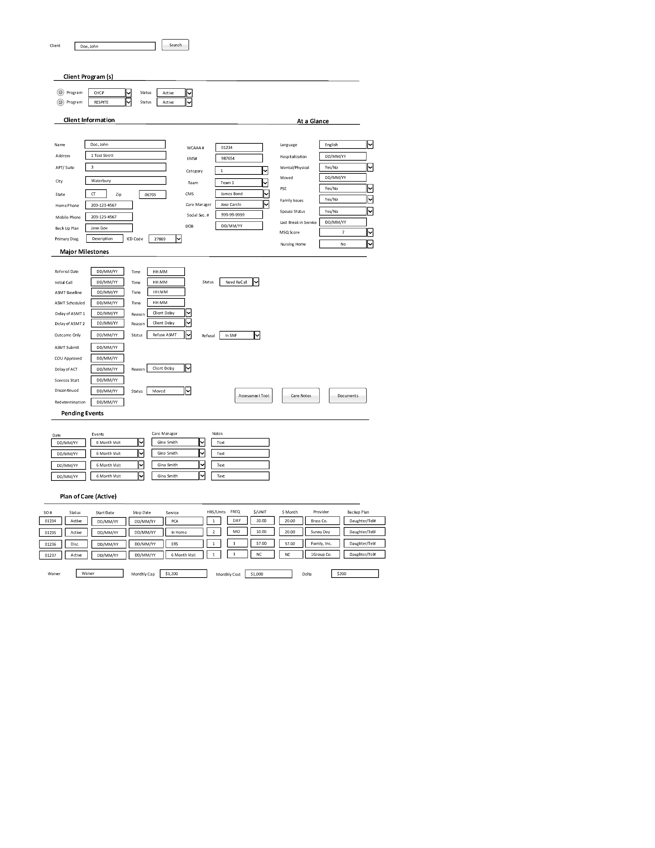

Care Manager Supervisor Dashboard

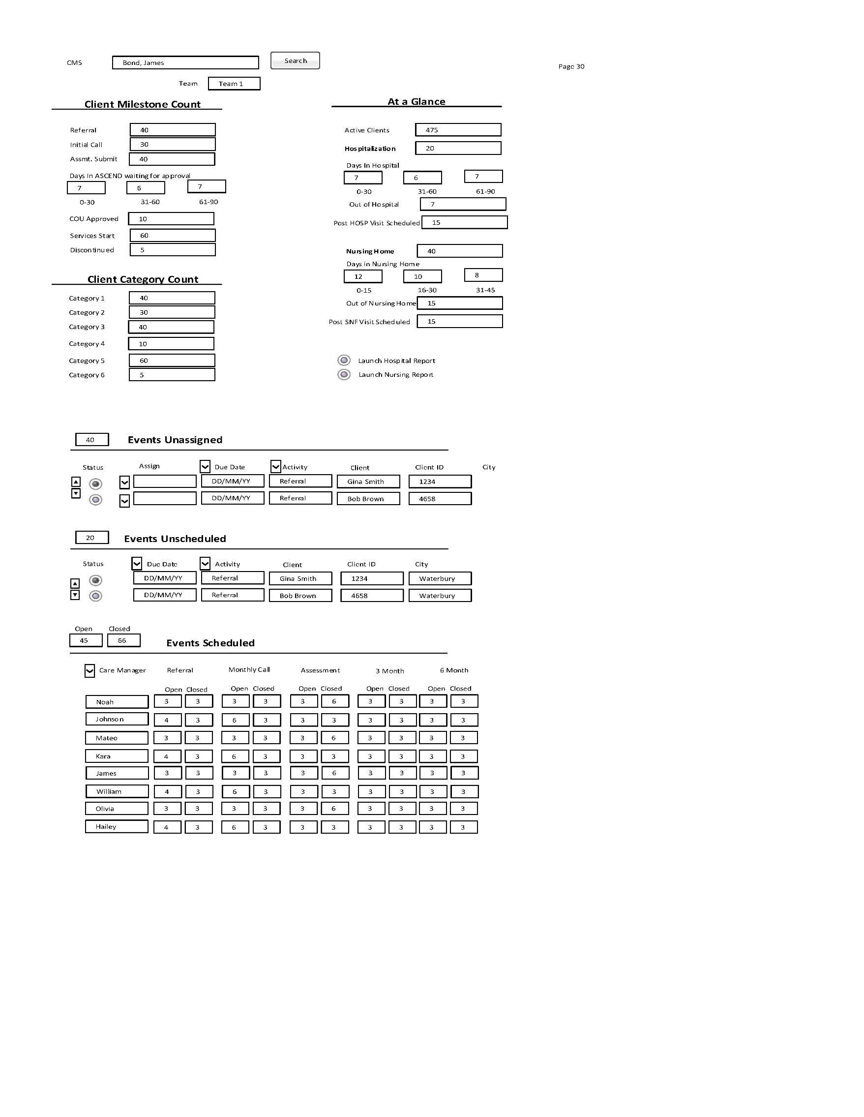

Care Manager Dashboard

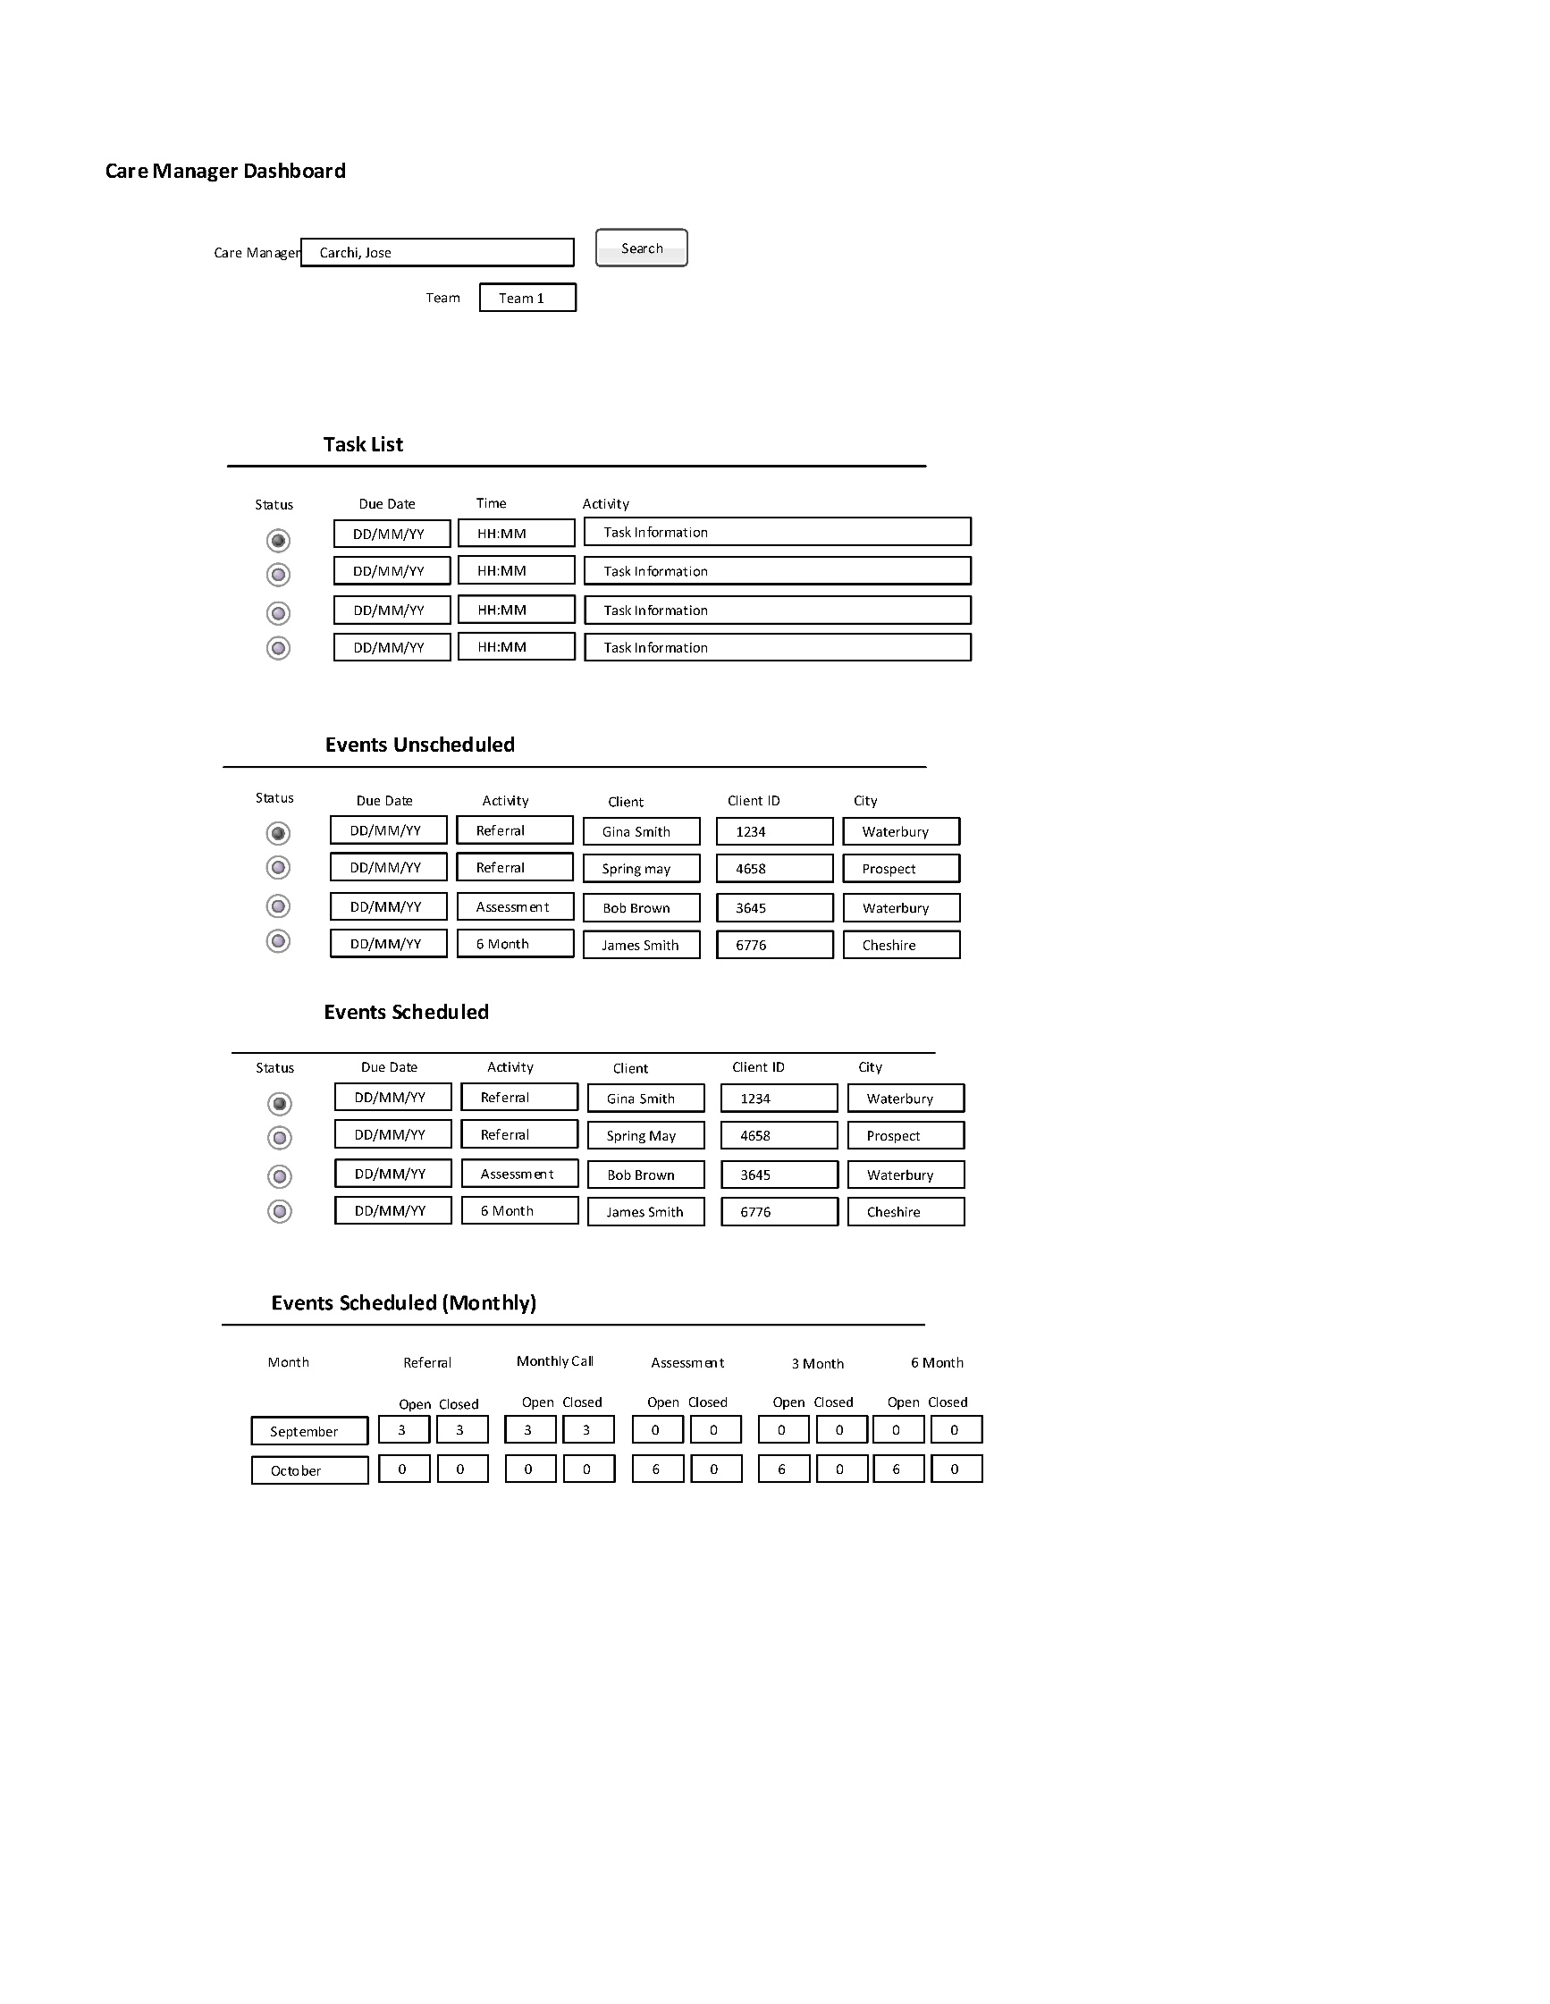

Care Manager Assistant Dashboard

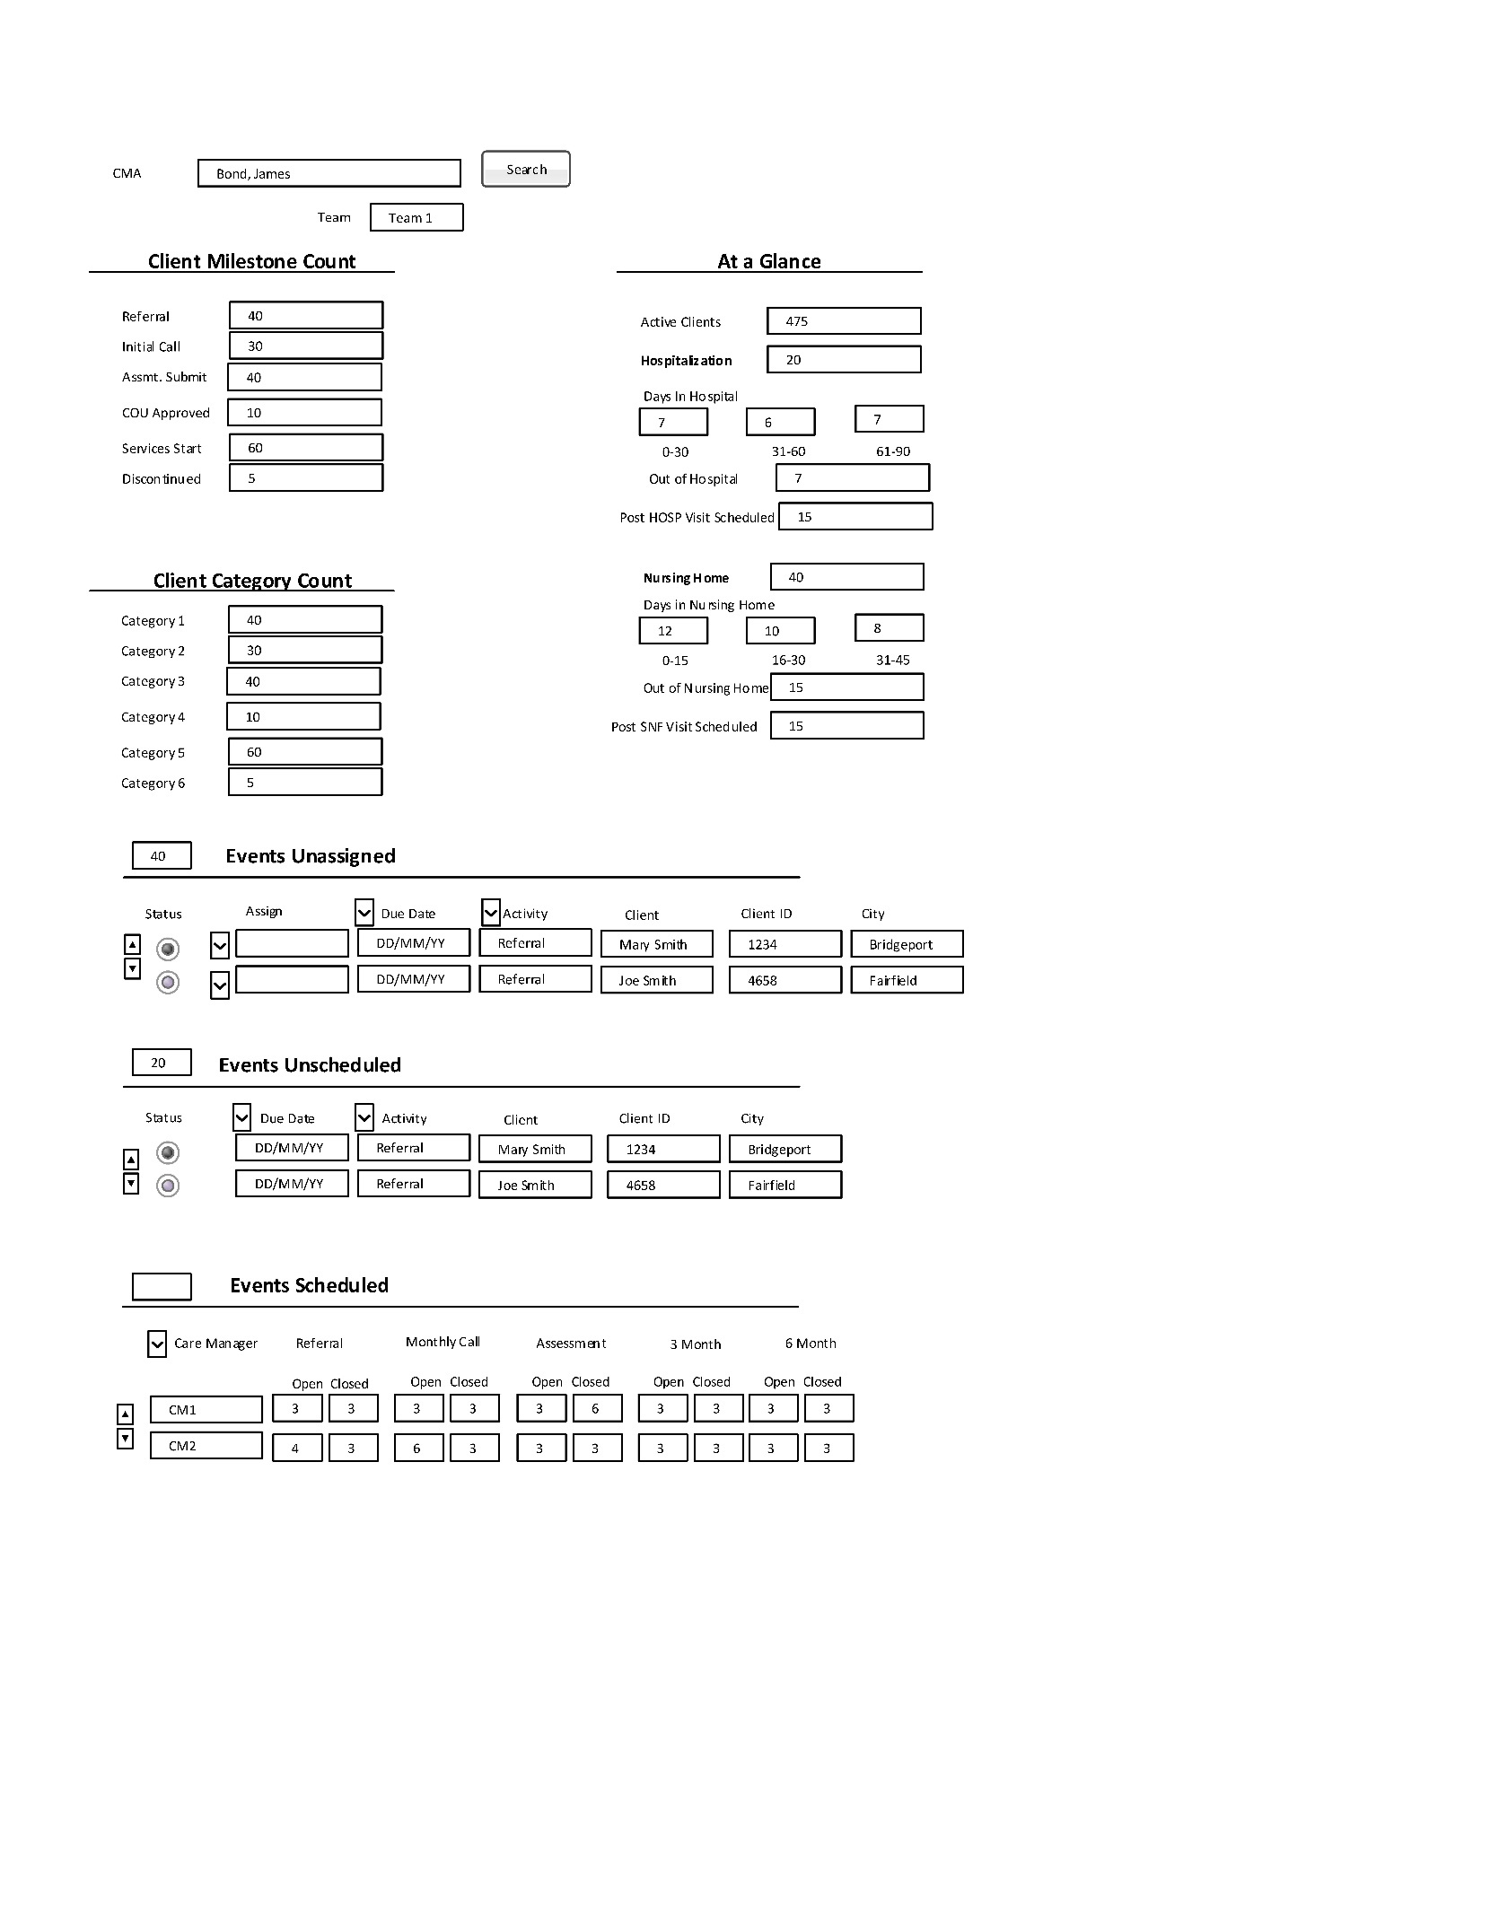

Eligibility Supervisor Dashboard

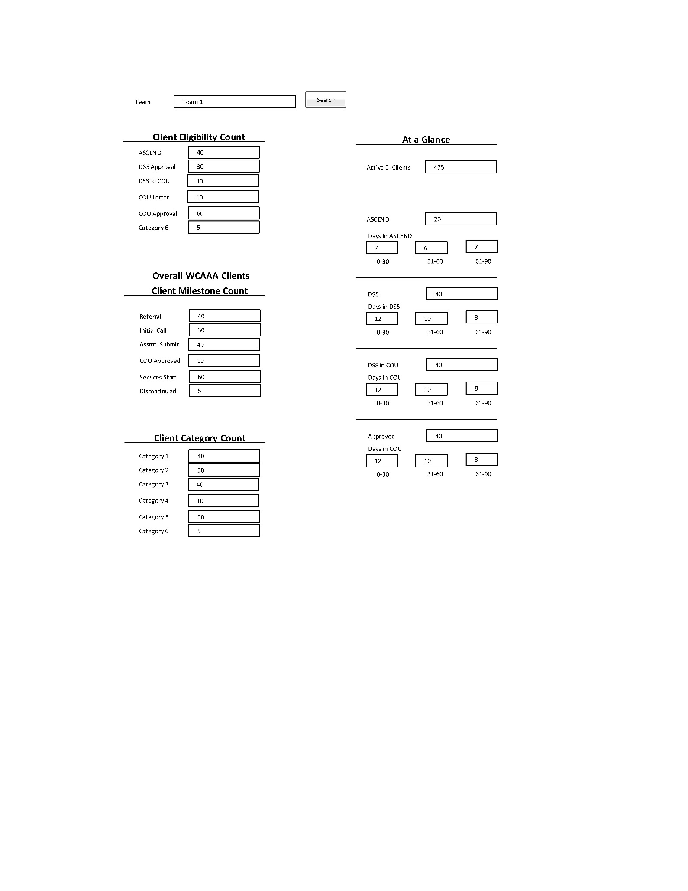

Eligibility Assistant Dashboard

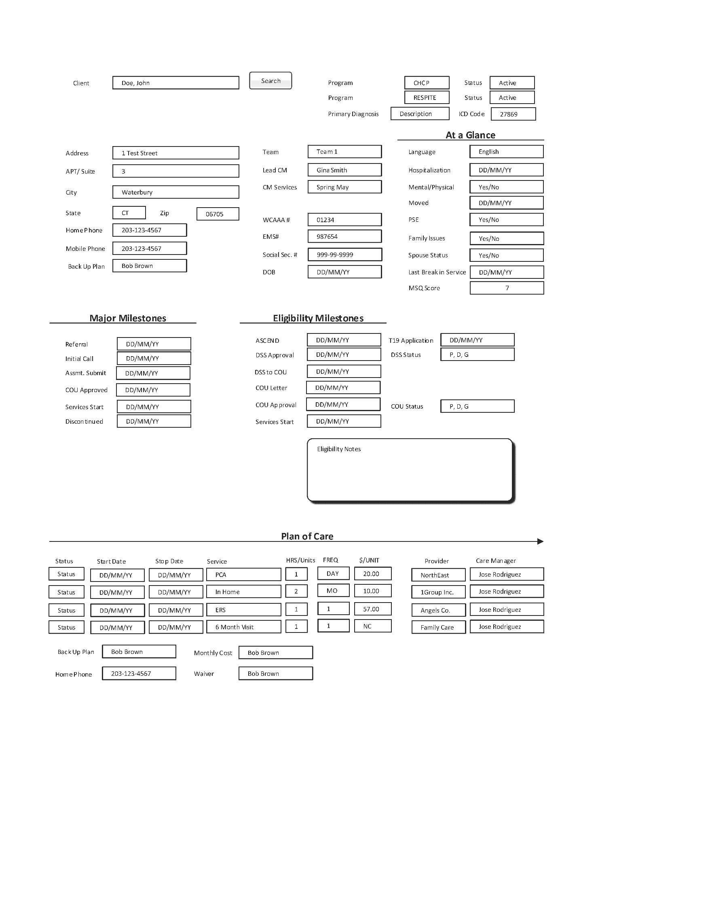

#### **exhibit 8** Goal Sheet

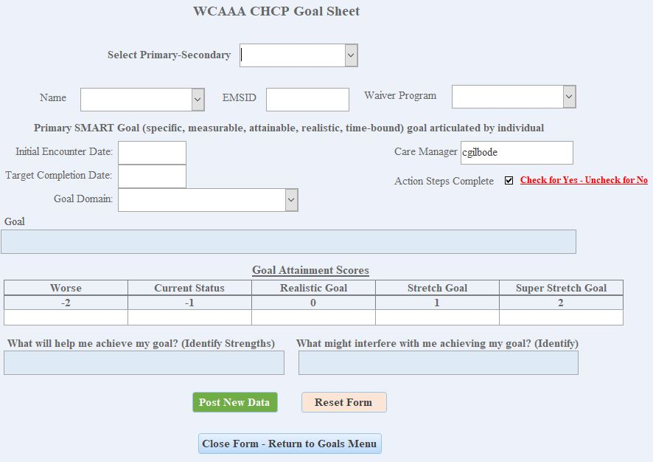

In the upcoming year, new goal requirements will be implemented, which are essential for our operations. The POC must be equipped to capture specific data related to the setting, monitoring, and establishment of new goals at designated intervals. Additionally, the POC should possess robust reporting capabilities to demonstrate progress against the benchmarks defined by COU.

As part of the onboarding process, each client will have goals established during the initial assessment. Monthly monitoring will necessitate the use of a goal form, along with detailed care notes in the POC system. This monitoring can be conducted by a CM, CMA, or CMS

#### exhibit 9 CLient face sheet



#### **exhibit 10** plan of care screenshots

See Embedded Word document with Plan of Care screen shots



#### **exhibit 11** PROC 11.0 Forms

The form section details the current paper documents utilized by WCAAA for Care Management Services. This list encompasses the majority of forms that require conversion to a digital format. The columns specify the source and destination for data within these forms.

**State forms change often and are expected to change/increase during the course of this project.**

|  |  |  |  |
| --- | --- | --- | --- |
| **WCAAA ICMS Forms** | | |  |
|  |  |  |  |
| **Process** | **Agency** | **Form #** | **Description** |
| Referral | CT DSS | N/A | Referral |
| Assessment | CT DSS | N/A | Universal Assessment |
| Assessment | CT DSS | W-997 | Notice of Liability (reimbursement) |
| Assessment | CTDSS | WCAAA | DSS Budget Exception Form |
| Assessment | CT DSS | W-889 | Informed Consent |
| Assessment | CT DSS | N/A | MINI COG |
| Assessment | CT DSS | W-1685 | Medical Insurance Information |
| Assessment | WCAAA | N/A | WCAAA Grievance and Appeal Process |
| Assessment | WCAAA | TBD | Signed Release Form |
| Assessment | CT DSS | W-298 | DSS Authorization for Disclosure of Information |
| Assessment | WCAAA | N/A | Client Signature Form |
| Assessment | WCAAA | N/A | HIPAA: Notice of Privacy Practices |
| Assessment | WCAAA | N/A | WCAAA Rights and Responsibilities |
| Assessment | CT DSS | W1LTSS | Application for Long-Term Services and Supports |
| Assessment | CT DSS | W-1J | Notification of Annuity Requirements |
| Assessment | CT DSS | W-1540 | Annuities and Your Eligibility for Long Term care Medical Services |
| Assessment | CT DSS | W-990 | CHCPE Your Rights and Responsibilities |
| Assessment | WCAAA | N/A | Permission / Restriction for Release of Information |
| Assessment | CT DSS | N/A | Individual Service Budget and Planning Tool Kit |
| Assessment | CT DSS | N/A | Community Options Participants Risk Agreement |
| Assessment | CT DSS | N/A | Community First Choice Participant Risk Agreement |
| Plan of Care | CT DSS | W-1510 | Universal Care Plan |
| Plan of Care | CT DSS | W-1510 Part II | Care Plan Cost Worksheet |
| Plan of Care | CT DSS | W-143 | Checklist to Authorize Care Management |
| Plan of Care | CTDSS | N/A | CFC Support and Planning Coach Authorization |
| Plan of Care | CT DSS | W-1596 | CHCPE Waiver Services |
| Plan of Care | CT DSS | W-1527 | Outcome Form |
| Plan of Care | WCAAA | TBD | Goal/Eligibility Checklist |
| Post Assess | WCAAA | TBD | Monthly Monitoring Note |
| Plan of Care | CT DSS | W-1532 | CHCPE Supervisory Review for Justification of PCA for Overnight and live-in Services |
| Plan of Care | CT DSS | W-1535 | PCA Care Plan Cost Neutrality Worksheet |
| Plan of Care | CT DSS | N/A | DSS CHCPE PCA Service Routing Slip |
| Post Assess | WCAAA | TBD | Initial Six-Month Monitoring Home Visit |
| Post Assess | WCAAA | TBD | Six Month Monitoring Home Visit |
| Post Assess | WCAAA | TBD | Annual Reassessment Profile |
| Post Assess | WCAAA | TBD | Goal Problem Eligibility Checklist (6 months) |
| Post Assess | CT DSS | W-675 | DSS Report Form for Protective Services for The Elderly |
| Plan of Care | CT DSS | W-1506 | Health Screen |
| Plan of Care | CT DSS | W-1529 | Discontinuance Recommendation Form |

Including the actual forms in the RFQ would be impractical. While most forms are one page, a few range from 5 to 15 pages, and the largest is approximately 147 pages.

#### **exhibit 12 and 13** HP MMIS Input and Return Files

While these two files are not within the project scope, they may assist the bidder in understanding two key outputs of the system. Please note that the requirement to export the included data could influence certain aspects of the system architecture.

 

PART II: GENERAL GUIDELINES

## Prime Objective

The primary objective of this Request for Quotation (RFQ) is to invite proposals from the designated vendor (hereinafter referred to as "SUPPLIER") to provide Salesforce software design, development, deployment, and training services, as outlined in the requirements specified in this document.

## Submittal of Questions/Oral Communications

All inquiries regarding any aspect of this RFQ must be submitted in writing via email to the WCAAA Authorized Contact at the email address provided in the RFQ Response Guidelines section (Part III) of this document. The WCAAA Authorized Contact will distribute copies of responses to relevant written questions to all prospective suppliers who have indicated their intention to submit a response to this RFQ.

Any communication initiated by the SUPPLIER with individuals other than the WCAAA Authorized Contact will be deemed a violation of the rules governing this RFQ and may result in the SUPPLIER being disqualified from consideration.

## Proposal Clarification

WCAAA reserves the right to request additional written or, at its discretion, oral information from the SUPPLIER at any time to clarify aspects of their proposal.

## award

WCAAA reserves the right to reject any or all proposals. Awards will be made to the SUPPLIER whose offer is deemed most advantageous to WCAAA, considering factors such as suitability of purpose, quality, service, prior experience, price, ability to deliver, and any other criteria that WCAAA considers to be in its best interest. Consequently, awards will not be determined based solely on price.

After reviewing all proposals submitted in response to this RFQ, WCAAA may request that selected suppliers participate in negotiations and provide revised pricing. However, WCAAA also reserves the right, at its sole discretion, to award contracts based on the initial offers received, without engaging in negotiations. Consequently, each initial proposal should include the SUPPLIER’s most competitive pricing.

## Final Agreement Terms

Enclosed in Appendix B of this document is the SUPPLIER Proposal Compliance Signature Sheet, which is intended to confirm the SUPPLIER's acceptance or partial acceptance of WCAAA’s terms and conditions. This signature sheet must be submitted with all proposals; any proposals received without this sheet will be disregarded.

# ****PART III: RFQ RESPONSE GUIDELINES****

This RFQ does not constitute an offer to contract. Acceptance of a proposal does not commit WCAAA to award a contract to the SUPPLIER, even if all requirements outlined in this RFQ are met, nor does it limit WCAAA's right to negotiate in its best interest. WCAAA reserves the right to contract with a supplier for reasons beyond the lowest price.

WCAAA will make selections based on initial submissions and encourages the SUPPLIER to provide their best and final pricing (BAFO) as part of the original submission.

Failure to answer any question in this RFQ may result in disqualification of the proposal. However, failure to meet a qualification or requirement will not necessarily lead to disqualification.

The SUPPLIER’s response to this RFQ will be regarded as an offer to establish a contract in accordance with the terms outlined in the proposal. WCAAA may, at its discretion, accept any or all parts of your proposal and incorporate them into a mutually acceptable contract.

## **Contract Phases**

There are five phases for the SUPPLIER contract: Requirements; Analysis and Design; Develop; Implementation and Support – as further detailed below:

**Phase 1: Requirements Gathering**

* Identify and document all project requirements.

**Phase 2: Analysis and Design**

* Define processes and design the Salesforce application, including user interface, database structure, data flow, and testing plan.

**Phase 3: Development**

* Code the application.
* Conduct testing and quality assurance.
* Perform a development review.
* Optimize workflows.
* Execute pilot testing.

**Phase 4: Implementation**

* Provide user training.
* Implement the application.
* Conduct user acceptance testing.

**Phase 5: Support**

* Deliver comprehensive documentation.
* Offer ongoing maintenance and support (including recurring costs).

**Project Start Date:** The project will commence immediately upon the selection of a qualified supplier.

**Project End Date:** August 7, 2025

## **RFQ Package (“RFQ”) and RFQ Response (“Response”)**

The complete RFQ Package (“RFQ”) comprises the email correspondence sent to the SUPPLIER, this document, and all associated appendices and attachments.

SUPPLIER is required to respond to this RFQ utilizing the designated response sections outlined in this document and its appendices and attachments. Responses submitted in any other template or format will not be considered.

## **RFQ Schedule**

The key dates for this RFQ are outlined below. WCAAA retains the right to amend these dates at its discretion and convenience, without liability. All vendors who indicate their intention to respond to this RFQ will be promptly notified of any changes.

**Schedule**

|  |  |
| --- | --- |
| **Activity** | **Date** |
| RFQ Issued | Monday 09/30/24 |
| Signed Acknowledgement of Bid and Non-Disclosure Agreement due (Required for existing application access only). | Monday 10/07/24 |
| RFQ Clarification Questions Due | Wednesday 10/09/24 |
| Answers to RFQ Clarification Questions Distributed | Tuesday 10/15/24 |
| RFQ Response Submission Deadline | Monday 10/21/24 |

Once RFQ responses have been received by WCAAA, it is anticipated that WCAAA may have questions for clarification. Respondents should ensure that key technical, service, and product staff are available for inquiries via email and phone as needed.   
Following the review of RFQ responses, WCAAA may select a shortlist of vendors for further consideration.

**Responses received after the Response Submission Deadline will not be considered.**

#### RFQ CLARIFICATION Questions and Answers

All inquiries regarding the RFQ should be directed via email to the authorized contact for WCAAA specified below. Please include the relevant details from this RFQ document in your correspondence:

* Part or Appendix Number
* Section Title
* Page Number
* Text Being Questioned
* Specific Question

The SUPPLIER is required to complete all clarification questions in the ICMS RFQ Clarification Questions document included in Attachment 2 of this document. Please email the completed RFQ Clarification Questions document to the authorized contact for WCAAA specified herein.

WCAAA will share all questions and answers with all SUPPLIERS that express intent to respond to this RFQ.

## WCAAA AUTHORIZED CONTACT for this RFQ

The authorized contact for this RFQ is listed below. This individual serves as your exclusive point of contact at WCAAA for all matters related to this RFQ. Please note that communication with any WCAAA employees other than the authorized contact can result in immediate disqualification from the RFQ process**.**

|  |  |  |
| --- | --- | --- |
| **Contact** | **Email** | **Phone** |
| Adel Mousa | RFQ@wcaaa.org | 203-725-3001 Ext. 152 |

## How to Respond

The SUPPLIER should submit an electronic copy of the RFQ Response in Microsoft Word format, except for the Pricing Response (Attachment 1), which must be provided in Microsoft Excel format. Responses should be submitted via email along with three paper copies. All correspondence, including the electronic RFQ Response submission, should be directed to the authorized contact for WCAAA specified above.

Paper copies of the RFQ Response should be delivered to the following mailing address:

Western Connecticut Area Agency on Aging

ICMS RFQ Attn: Adel Mousa

84 Progress Lane, 2nd Floor

Waterbury, CT, 06705

## Format of Response

The entire RFQ Response (“Response”) consists of this document along with all appendices and attachments (excluding embedded Exhibits) filled in and executed by the SUPPLIER where applicable, as well as any additional attachments included by the SUPPLIER in their response.

The SUPPLIER is required to respond to this RFQ using the provided response sections in this document, along with all appendices and attachments. It is essential that the SUPPLIER follows the instructions, outline, and format specified in this RFQ document. Proposals submitted in a different template or format will not be accepted**.**

Functional and technical responses should clearly articulate how the SUPPLIER’s solution will effectively meet WCAAA’s needs. The SUPPLIER should demonstrate their capability to provide a beneficial solution for WCAAA. Statements such as “SUPPLIER understands” or any paraphrasing of the RFQ or other contract requirements are generally insufficient.

*Note: While the requirements outlined in this RFQ are specific, we acknowledge that the SUPPLIER may not meet all stated criteria. The SUPPLIER should document any exceptions to the requirements they are unable to fulfill and provide recommendations for alternative approaches that could offer enhanced value, service, and/or cost savings.*

## **selection criteria and Evaluation Factors for Award**

WCAAA will award a contract to the SUPPLIER whose solution is considered most advantageous, based on several factors, including but not limited to:

1) Organizational Stability and Service Offering Maturity

2) Technical Approach

3) Past Performance

4) Implementation Experience

5) Experience with Not-For-Profit Organizations

6) Price

## **Costs**

WCAAA will **not** reimburse respondents for any costs incurred in connection with their submissions in response to this RFQ.

## **Modification, Suspension, Withdrawal of RFQ or RFQ Process**

The SUPPLIER acknowledges that WCAAA reserves the right, in its sole discretion, to amend any portion of this RFQ, to suspend the RFQ process, to procure the services requested under this RFQ through a method other than the consideration of proposals submitted in response to this RFQ, or to decide not to procure the products and/or services related to this RFQ.

## **Accuracy of SUPPLIER Information**

The SUPPLIER agrees and acknowledges that any proposal submitted in response to this RFQ constitutes a firm offer regarding price, terms and conditions, and shall remain binding for a minimum of 150 days following the submission deadline.

## **Confidentiality**

**WCAAA’s expectations regarding confidentiality are outlined in the Non-Disclosure Agreement, which your firm is required to sign and submit in accordance with the RFQ schedule specified in the RFQ document.** The execution of the Non-Disclosure Agreement signifies our mutual commitment to confidentiality. The RFQ and Response will be treated as WCAAA Confidential Information. The SUPPLIER agrees to maintain the confidentiality of WCAAA’s proprietary information disclosed in the RFQ document and all its attachments and will not disclose this information to any third party. The SUPPLIER shall exercise no less care in safeguarding WCAAA’s proprietary information than it uses to protect its own proprietary information of similar importance; however, this standard of care shall not be less than reasonable.

## **General Financial Requirements**

SUPPLIER must provide pricing information using the Pricing Response Document (Attachment 1).

#### Pricing Structure and Fees

Pricing for the specified services outlined in the RFQ must be submitted in the WCAAA Pricing Response Document (Attachment 1). Both WCAAA and the SUPPLIER understand and accept that the pricing encompasses all necessary costs, including any applicable taxes, duties, licensing, and leasing fees associated with the provision of the services.

The SUPPLIER is required to clearly identify and explain all assumptions made in determining its pricing.

Any applicable taxes, duties, licensing and leasing fees, as well as other pass-through charges, must be specified in the WCAAA Pricing Response Document (Attachment 1) and presented separately from the service charges.

#### Best and Final Offer (BAFO)

The SUPPLIER is required to submit a comprehensive best and final offer to support the services outlined in this RFQ. The pricing must be all-inclusive, covering all labor and materials necessary to deliver the specified services. The SUPPLIER assumes full liability for any omissions. Additionally, the SUPPLIER must clarify how overtime is addressed for on-site support services, if applicable.

#### Ownership of intellectual property

**1.** **Ownership Rights:** The Western Connecticut Area Agency on Aging (the “Agency”) shall own all rights, title, and interest in and to the software, including all source code, object code, documentation, modifications, enhancements, and any related intellectual property (collectively, the “Software”) developed under this Request for Quotation (RFQ).

**2.** **Transfer of Rights:** Upon full payment for the Software, all rights, title, and interest in the Software shall be irrevocably transferred to the Agency. The Agency shall have the perpetual and unlimited right to use, modify, reproduce, and distribute the Software in any manner it deems appropriate.

**3.** **No License Required:** The Agency shall not be required to pay any licensing fees or royalties for the use of the Software. All rights granted to the Agency shall be exclusive and shall not be subject to any restrictions or conditions.

**4.** **Third-Party Claims:** The SUPPLIER agrees to defend, indemnify, and hold the Agency harmless from any claims, losses, or damages arising from any third-party claims related to the ownership and use of the Software.

**5.** **Future Modifications:** Any modifications or enhancements made to the Software, whether performed by the SUPPLIER or any third party, shall also be owned by the Agency under the same terms as outlined herein.

**6.** **Confidentiality and Non-Disclosure:** The SUPPLIER agrees to treat all aspects of the Software, including the source code and any related documentation, as confidential and shall not disclose it to any third party without the prior written consent of the Agency.

**7.** **Survival of Terms:** The provisions of this section shall survive the termination or expiration of any agreement arising from this RFQ.

**8.** **Salesforce Licensing:** The Agency agrees to pay the necessary licensing fees for Salesforce required to support the Software. However, the Agency shall not be responsible for any licensing fees or costs associated with additional services, features, or enhancements beyond those specifically required for the operation of the Software as outlined in this RFQ.

**9.** **SUPPLIER Responsibilities:** The SUPPLIER shall be responsible for ensuring that all software developed operates within the scope of the Salesforce licensing procured by the Agency and must communicate any potential additional licensing needs before implementation.

RFQ RESPONSE TEMPLATES

The remainder of this document, starting at Appendix B, is a template for SUPPLIER’s response to this RFQ. (SUPPLIER should already have completed and returned to WCAAA

Appendix A prior to submitting a proposal)

**SUPPLIER is required to complete all forms provided below and respond to all the RFQ questions and requirements using the templates provided below.**

SUPPLIER is required to complete all appendices **without removing them** from this document, complete Attachments 1 and 2 and return the **whole** RFQ document (including Part I, Part II and Part III) with the completed appendices and Attachments 1 and 2.

# APPENDIX A: ACKNOWLEDGEMENT OF BID INVITATION Due (10/07/24)

WCAAA invites you to respond to its Request for Quotation (RFQ) for Salesforce Development Services.

Please complete and return this form and the enclosed WCAAA NDA (Non-Disclosure Agreement) document by 10/07/2024

We, the undersigned, acknowledge receipt of WCAAA’s Request for Quotation for Salesforce Development Services.

|  |  |
| --- | --- |
|  | We intend |
|  | We do not intend |

to submit a proposal

We also acknowledge that the package, in its entirety, is confidential and proprietary to WCAAA and contains privileged information. We agree not to copy or otherwise distribute this package or reveal its contents to any third party. Enclosed with this form is a signed copy of WCAAA’s Non-Disclosure Agreement document.

|  |  |
| --- | --- |
| SUPPLIER Name: |  |
| Name of Authorized SUPPLIER Representative: |  |
| Signature: |  |
| Title: |  |
| Phone Number: |  |
| Email: |  |

# APPENDIX B: SUPPLIER PROPOSAL COMPLIANCE SHEET

**INSTRUCTIONS:** When submitting your proposal, it is necessary to attach this signature sheet. Please sign below indicating whether your proposal is (A) in accordance with all the terms and conditions OR (B) not in accordance with all the terms and conditions.

Please sign and date EITHER Section A or Section B below. Please do NOT sign both sections.

**SECTION A:** By signing below, we indicate that we have reviewed WCAAA’s Agreement thoroughly **and agree to all its terms and conditions:**

|  |  |  |  |
| --- | --- | --- | --- |
| Signed: |  | Date: |  |
|  | (Signature of Authorized Officer) |  |  |

|  |  |
| --- | --- |
| SUPPLIER Name |  |

**SECTION B:** By signing below, we indicate that we have reviewed WCAAA’s Agreement thoroughly and agree to **all the terms and conditions, except as clearly identified in Section _____ of our attached proposal:**

|  |  |  |  |
| --- | --- | --- | --- |
| Signed: |  | Date: |  |
|  | (Signature of Authorized Officer) |  |  |

|  |  |
| --- | --- |
| SUPPLIER Name |  |

# APPENDIX C: RFQ REQUIREMENTS

This section outlines WCAAA's requirements for Salesforce Development Services. The SUPPLIER is required to utilize this template to respond to the specified requirements below. Attachments should only be included to clarify responses within this template. **Proposals that do not use this template or fail to adhere to the response guidelines outlined in this document will not be considered.**

It is imperative that all requirements are thoroughly addressed. The SUPPLIER should provide a brief explanation of how each requirement is met, as a simple "yes" or "no" response is typically insufficient. A few sentences should adequately address most items. **Failure to comply with these instructions will result in the rejection of the proposal.**

## **GENERAL INFORMATION**

Please provide the following background information:

| **Req**  **#** | **Requirement** | **Description** |
| --- | --- | --- |
|  | SUPPLIER Name |  |
|  | SUPPLIER Address |  |
|  | Primary Contact Name |  |
|  | Contact Phone Number |  |
|  | Contact Email Address |  |
|  | Is Salesforce Development your core service, or is it offered as an add-on? |  |
|  | How many customers have over 100 users, and what percentage does this represent of your total customer base |  |
|  | What types and sizes of customers does your company primarily focus on? |  |
|  | Total number of employees dedicated to your business? |  |

## **Staff Resumes**

Resumes for the proposed Project Manager and primary technical personnel should be included with the submission.

## **Training**

The SUPPLIER is required to provide a detailed description of the training services offered for the areas outlined in this RFQ.

|  |  |  |
| --- | --- | --- |
| **Req**  **#** | **Requirement** | **Description** |
|  | Describe the training you provide to end users, and application administrators. |  |

## **Other Optional Services**

The scope of this RFQ is limited to Salesforce Development services only, and WCAAA does not plan to procure any other services at this time. However, WCAAA may express interest in the SUPPLIER's capabilities in related services in the future.

The SUPPLIER is requested to provide a detailed description of its solution roadmap for future services, including:

| **Req #** | **Requirement** | **Description** |
| --- | --- | --- |
|  | Describe any additional capabilities you currently provide. |  |
|  | Describe any other current or future SUPPLIER products/services that might be of interest to WCAAA. |  |

## **References**

The SUPPLIER is requested to provide **three** references for previous Salesforce Development services delivered. These references should reflect projects similar in size, scope, and complexity to those of WCAAA, including full implementation, data migration, and ongoing management and support. For each reference, please include the following information:

|  |  |
| --- | --- |
| **Client Reference #1** | |
| Customer Name |  |
| Customer Contact Name, Title, Email and Phone Number |  |
| Description (Include information about the client’s industry, number of users, locations) |  |
| Services Provided to Client by SUPPLIER |  |
| Describe the solution provided to this customer. |  |
| SUPPLIER Roles & Responsibilities |  |

|  |  |
| --- | --- |
| **Client Reference #2** | |
| Customer Name |  |
| Customer Contact Name, Title, Email and Phone Number |  |
| Description (Include information about the client’s industry, number of users, locations) |  |
| Services Provided to Client by SUPPLIER |  |
| Describe the solution provided to this customer. |  |
| SUPPLIER Roles & Responsibilities |  |

|  |  |
| --- | --- |
| **Client Reference #3** | |
| Customer Name |  |
| Customer Contact Name, Title, Email and Phone Number |  |
| Description (Include information about the client’s industry, number of users, locations) |  |
| Services Provided to Client by SUPPLIER |  |
| Describe the solution provided to this customer. |  |
| SUPPLIER Roles & Responsibilities |  |

# ATTACHMENT 1: PRICING RESPONSE DOCUMENT

**See embedded Excel document for Pricing Response File**



# ATTACHMENT 2: RFQ CLARIFICATION QUESTIONS DOCUMENT

**See embedded Excel document for the Clarification Questions Template**



# ATTACHMENT 3: Vendor Solution Overview Document

**Please submit an overview or your proposed solution following the information/instructions provided within the following doc**



**End of Request for Quotation for Integrated Care Management System (ICMS) document**